## Chapter 1

## INTRODUCTION

## Chapter 2

## PROJECTREQUIREMENTS

### HARDWARE

* Processor :inteli52.4GHz, 64bitprocessor
* Ram :4GBRAM
* HardDisk :50GB

**SOFTWARE**

* OperatingSystem :WINDOWS 10
* ProgrammingLanguage : JAVA
* Database : MY SQL

**Chapter 3**

**Literature Survey**

**Chapter 4**

**Literature Survey & Problem Statement**

**Chapter 5**

**System Design**

**Chapter 6**

**Implementation**

**Chapter 7**

**Testing**

**Chapter 8**

**RESULTS**

**(Ex: Snapshots)**

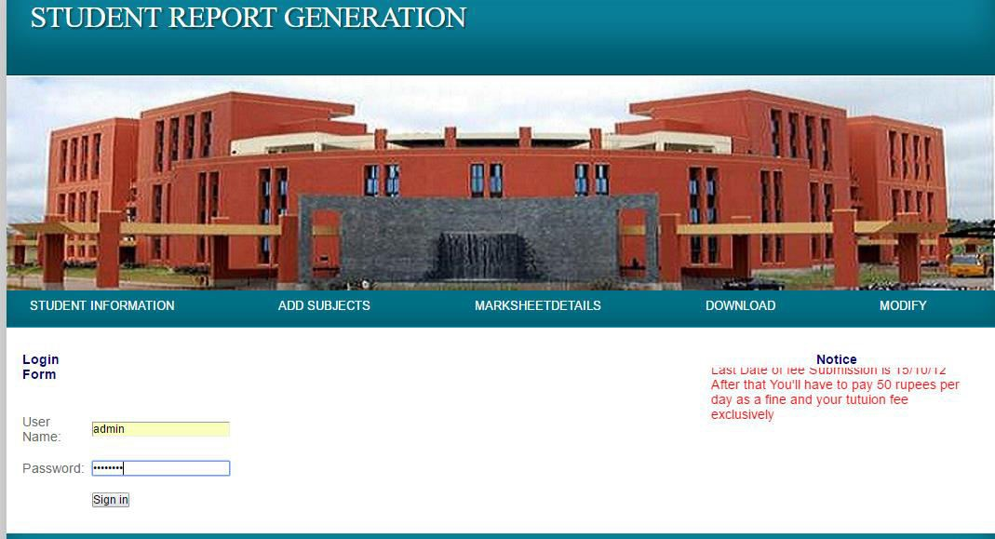

**Fig 8.1welcomepage**

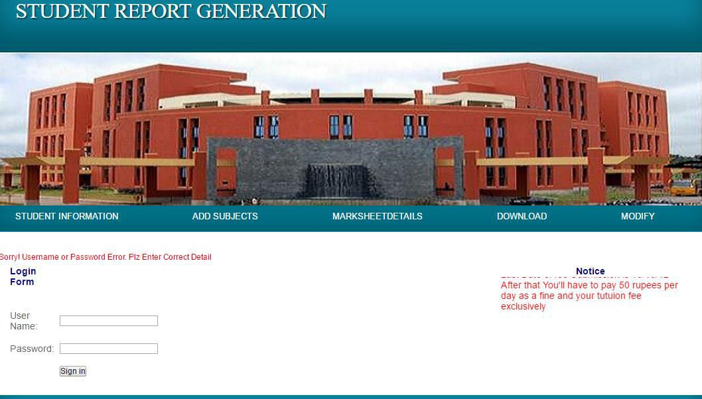

**Fig 8.2 loginformadminto loginusingusernameand password.**

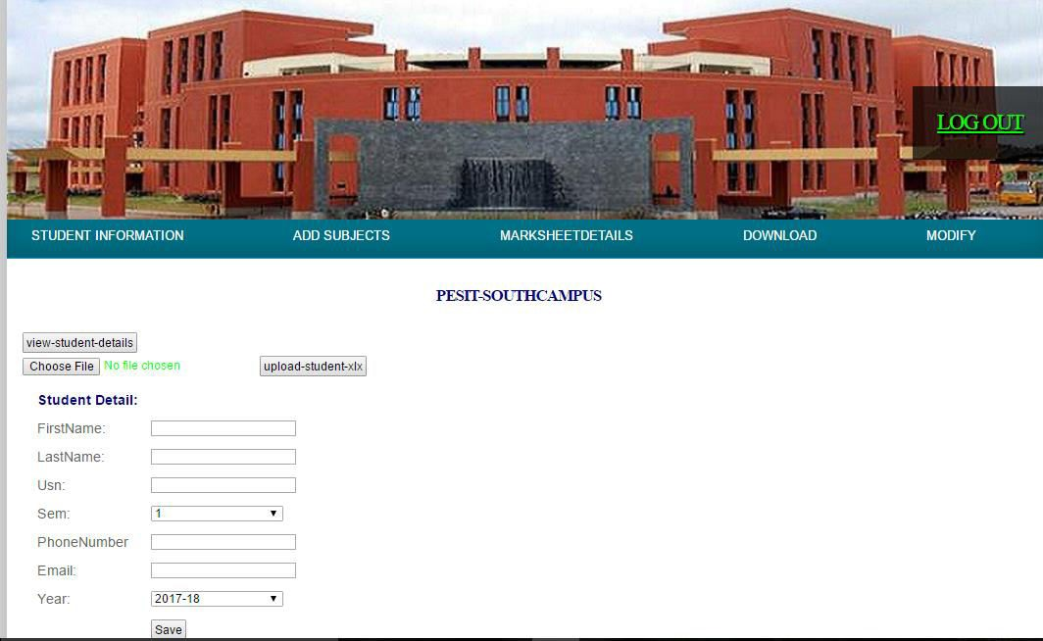

**Fig 8.3 Add studentinfromation**

**Table 8.1 viewstudentinformation**

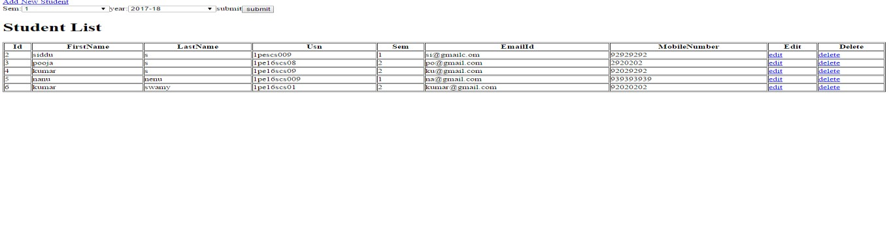

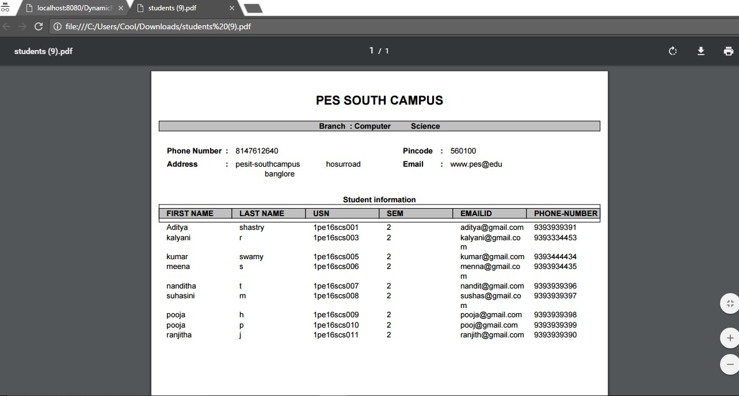

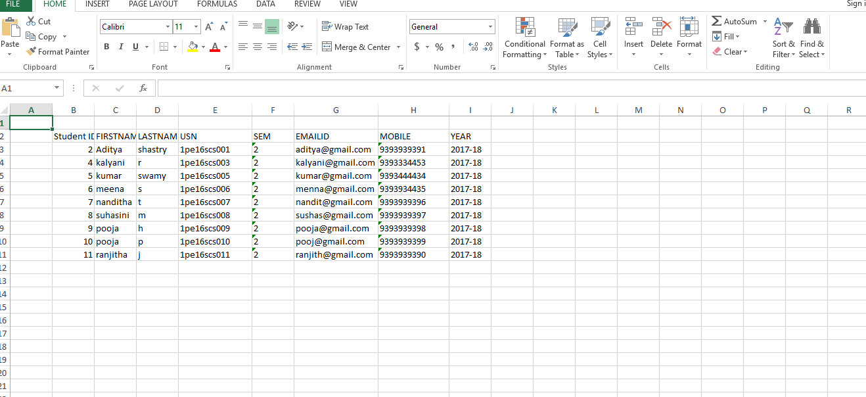

**Conclusion**

**Reference**